PRE-AP 8TH GRADE SUMMER READING ASSIGNMENT
“And then there were none” map project
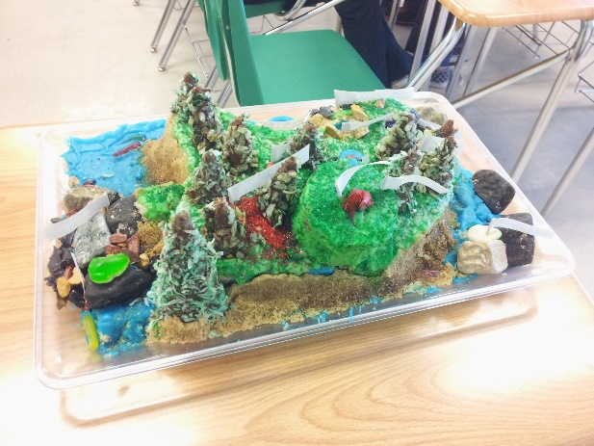
SPOILER ALERT! CRAZY THINGS HAPPEN TO THE MAIN CHARACTERS IN THE NOVEL! Create a map depicting the setting, and major events of the novel. Your map should have “event markers” that detail characters’ fates in the location that it takes place. Your map can resemble a game board (think CLUE®!) that has various models or pieces representing characters and scenery. Each event marker should have a direct quotation from the novel using parenthetical citation= (Author’s last name, page number). Example: (Christie, 85).
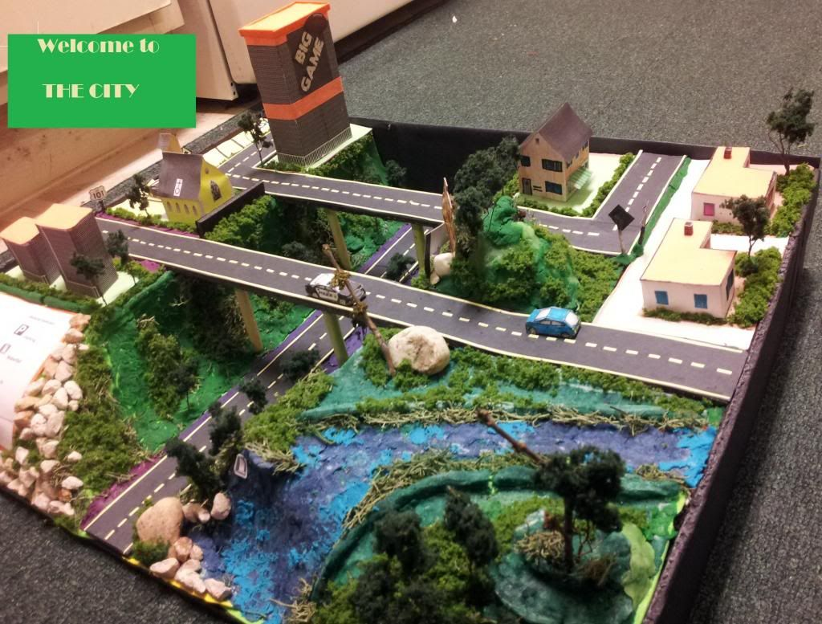
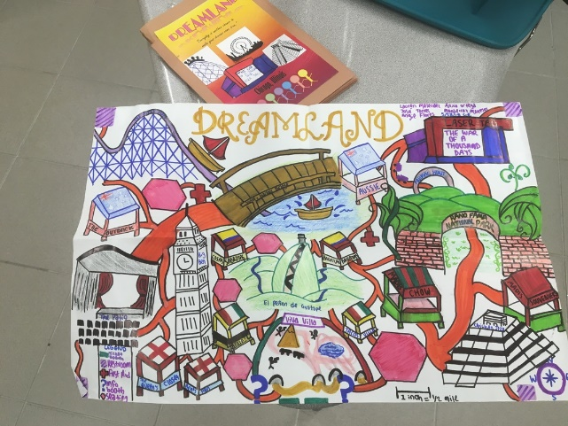

SUPPLIES:
1 Poster board or Cardboard piece (platform)
1 glue stick/hot glue gun with sticks
Small models (bought or homemade)
Color Options: Markers, colored pencils, paint, etc.
Event markers: cut index cards/notebook paper, toothpicks
REQUIREMENTS:
Your map must demonstrate that you have read the entire novel.
Your map must provide a clear representation of the setting of the story.
ALL characters must be present at their designated event markers.
Your event markers should be placed in the location of the island that an incident occurred along with the character involved. (Hint, hint: objects will be involved as well)

SUGGESTIONS:
Your map can resemble a CLUE® board game.
Your characters can resemble game pieces.
You can use toothpicks or small kabob sticks to hold up your event markers.
Your event markers can be recorded on index cards that are cut in half.
Hot glue guns are the best!

I will best be available to contact for any questions/concerns via email at arispeb@oeisd.org. Feel free to email me this summer to introduce yourself! I’m looking forward to meeting all of you!

